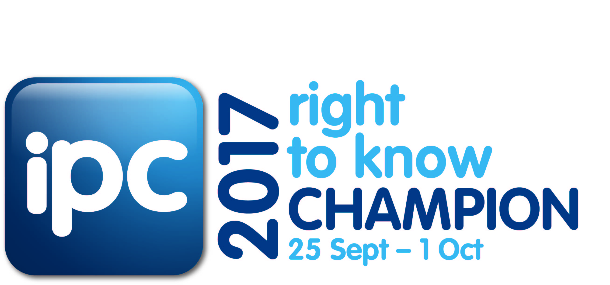

**Suggested copy for Intranet**

**Championing Right to Know 2017**

[insert organisation’s name here] is an official Champion in the Information and Privacy Commission’s [Right to Know Week 2017](http://www.ipc.nsw.gov.au/news-media/events/right-know-week-2017) campaign held from 25 September - 1 October 2017.

Right to Know Day (RTK) (28 September 2017) is an international annual event that aims to increase awareness of individuals’ right of access to government information and open, transparent governance.

This year’s theme is ‘*Right to Information: Open and accountable government and the media’s role*’, where:

* Open government builds community trust
* Government transparency strengthens community participation and our democracy
* Community access to government-held information keeps us accountable and transparent.

This means that:

* I have a right to access government information
* I have a responsibility to release government information
* Communities have the right to know. Governments have a responsibility to share.

Each of us has a part to play in facilitating open access to information, and building the NSW community’s confidence in open governance. By keeping accurate records, being honest and accountable in your work, and promoting the individual’s right to access information by engaging with stakeholders, you can do your bit to spread the RTK 2017 message.

**Suggested copy for Website**

**Right to Know Week 2017**

[insert organisation’s name here] has joined the Information and Privacy Commission of NSW as an official Champion during [Right to Know Week 2017](http://www.ipc.nsw.gov.au/news-media/events/right-know-week-2017) (25 September – 1 October 2017). The right of every individual in NSW to access government held information is protected by the *Government Information (Public Access) Act 2009.*

All NSW citizens have a legal enforceable right to access most information held by NSW government and agencies.

This year, the Information Commissioner and NSW Open Data Advocate, Elizabeth Tydd encourages agencies to embrace the theme ‘*Right to Information: Open and Accountable Government and the Media’s Role*’ by maintaining accurate records, proactively releasing information, and inviting and managing community consultation on projects.

Most publicly available information can be found on our website, and more detailed requests can be directed to our Right to Information Unit (suggest link). We are proud to promote our commitment to open access to information for the people of NSW as an official Champion for Right to Know Week 2017.

**Suggested image:** Web Banner

**Suggested message from head of Agency to staff**

**Right to Know 2017 Champion**

This year [insert organisation’s name here] is pleased be a Champion of the Information and Privacy Commission’s [Right to Know Week 2017](http://www.ipc.nsw.gov.au/news-media/events/right-know-week-2017) campaign held from 25 September - 1 October 2017. Right to Know Week marks the international Right to Know Day that is celebrated annually on 28 September.

This year’s theme is ‘*Right to Information: Open and accountable government and the media’s role*’, where:

* Open government builds community trust
* Government transparency strengthens community participation and our democracy
* Community access to government-held information keeps us accountable and transparent.

This means that:

* I have a right to access government information
* I have a responsibility to release government information
* Communities have the right to know. Governments have a responsibility to share.

As employees of [insert organisation name here], each of us has a part to play in facilitating open access to information and increasing the NSW community’s awareness of their rights, and confidence in government decision-making where open and transparent governance is at the forefront.

[Insert organisation’s name here] is committed to promoting open access to information by releasing as much information as possible informally and more formally through our right to information/governance unit. I also encourage staff to be accountable during this process and actively engage with our stakeholders.

**Suggested image:** IPC posters