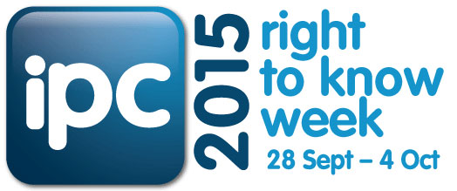
SUGGESTED CHAMPION TWEETS /SOCIAL MEDIA STATUS UPDATES RIGHT TO KNOW WEEK 2015
These messages have been developed for Champions of IPC’s Right to Know Week 2015 campaign.
Tweet or update your organisation’s social media status as often as you like in the lead up to and during Right to Know Week 2015 (28 September – 4 October 2015).
You are welcome to craft your own messages in relation to Right to Know Week 2015.
Remember:
- Use the official Right to Know hash tag #RTK2015.
- Text highlighted yellow indicates a link you will need to insert or generate before tweeting/posting
- If your organisation permits, use Bitly to shorten links
- Consider using the hash tag #opengov to increase the reach of your organisation’s tweets/social media activity.
- The IPC will also be posting on Twitter, so please re-tweet any of our messages throughout the week.
Our Twitter handle is: @IPCNSW
- Follow any relevant policies or guidelines issued by your organisation.

In the lead up to Right to Know Week

1 | We are getting ready for Right to Know Week in NSW 28 Sept - 4 Oct #RTK2015 #IPCNSW #opengov
2 | Do you know you can access government held information? For more information visit: (insert link to IPC website or your organisation's GIPA page) #RTK2015 #SwitchOnOpenGov
3 | We are proud to be a Champion of IPC's Right to Know Week 2015 campaign #RTK2015 showing our commitment to open government #SwitchOnOpenGov (link to IPC's RTK webpage)
Start of Right to Know Week
4 | 28 September 2015 | Happy International Right to Know Day. We are a proud Champion of #IPCNSW's Right to Know campaign (suggest link to your website RTK related news item/carousel/media release) #RTK2015 #SwitchOnOpenGov
Throughout RTK Week
5 | We are championing your right to know in NSW #RTK2015 #IPCNSW #SwitchOnOpenGov You have a Right to Know!
6 | You can access information held by NSW government. Do you know your rights?. Find out more at (insert link to IPC website or your organisation's GIPA page) #RTK2015 #SwitchOnOpenGov
7 | We are Switching on Open Government and championing your right to access information. (link to ipc website) #RTK2015 #opengov #SwitchOnOpenGov

