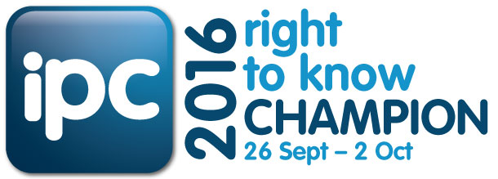

Suggested copy for Intranet
Championing Right to Know 2016 – Open Government in Action
[insert organisation’s name here] is an official Champion in the Information and Privacy Commission’s Right to Know Week 2016 campaign held from 26 September to 2 October 2016.
Right to Know Day (RTK) (28 September 2016) is an international annual event which aims to increase awareness of individuals’ right of access to government information and open, transparent governance.
The themes for this year’s campaign are:
- Open Government in Action – promoting a representative government that is transparent, accessible and responsive to its citizens
- You have a right to know – citizens have a legal enforceable right to access most information held by NSW government and agencies.
Each of us has a part to play in facilitating open access to information, and building the NSW community’s confidence in open governance. By keeping accurate records, being honest and accountable in your work, and promoting the individual’s right to access information by engaging with stakeholders, you can do your bit to spread the RTK 2016 message.
For more information visit http://www.ipc.nsw.gov.au/news-media/events/right-know-week-2016
Suggested copy for Website
‘Open Government in Action’ during Right to Know Week 2016
[insert organisation’s name here] has joined the Information and Privacy Commission of NSW as an official Champion during Right to Know Week 2016 (26 September – 2 October 2016). The right of every individual in NSW to access government held information is protected by the Government Information (Public Access) Act 2009.
All NSW citizens have a legal enforceable right to access most information held by NSW government and agencies.
This year, the Information Commissioner and NSW Open Data Advocate, Elizabeth Tydd encourages agencies to embrace the theme ‘Open Government in Action’ by maintaining accurate records, proactively releasing information, inviting and managing community consultation on projects
Most publicly available information can be found on our website, and more detailed requests can be directed to our Right to Information Unit (suggest link). We are proud to promote our commitment to open access to information for the people of NSW as an official Champion for Right to Know Week 2016.
Suggested image: Web Banner
Suggested message from head of Agency to staff
Right to Know 2016 Champion – Open Government in Action
This year [insert organisation’s name here] is pleased be a Champion of the Information and Privacy Commission’s Right to Know Week 2016 campaign held from 26 September to 2 October 2016. Right to Know Week marks the international Right to Know Day which is celebrated annually on 28 September.
The themes for this year’s campaign are:
- Open Government in Action – promoting a representative government that is transparent, accessible and responsive to its citizens.
- You have a right to know – citizens have a legal enforceable right to access most information held by NSW government and agencies.
As employees of [insert organisation name here], each of us has a part to play in facilitating open access to information and increasing the NSW community’s awareness of their rights, and confidence in government decision-making where open and transparent governance is at the forefront.
[Insert organisation’s name here] is committed to promoting open access to information by releasing as much information as possible informally and more formally through our right to information/governance unit. I also encourage staff to be accountable during this process and actively engage with our stakeholders.
You can find out more about RTK 16 and the Government Information (Public Access) Act 2009 by visiting www.ipc.nsw.gov.au
Suggested image: IPC posters

